**Circuit Guide:**

Usually, circuits are represented with schematics! A schematic is the most common, basic representation of a circuit where each part (or component) is represented by their own unique symbol. Lines are drawn from symbol to symbol in order to represent how the components should be electrically connected to one another. Below are pictures of the components that are in your kit next to their associated schematic symbol.

Battery/Voltage Supply:

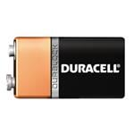 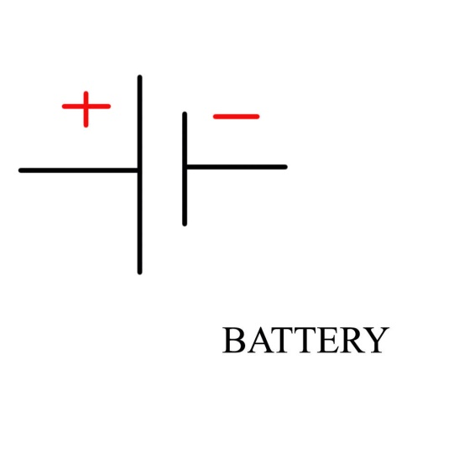

Light Emitting Diode (LED):

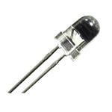 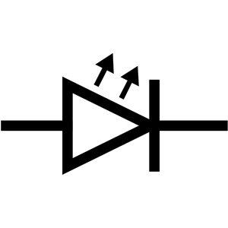

Resistor:  
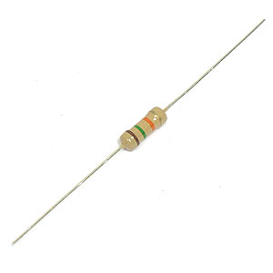 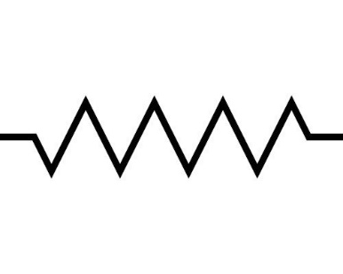

Potentiometer (Variable Resistor):

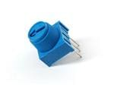 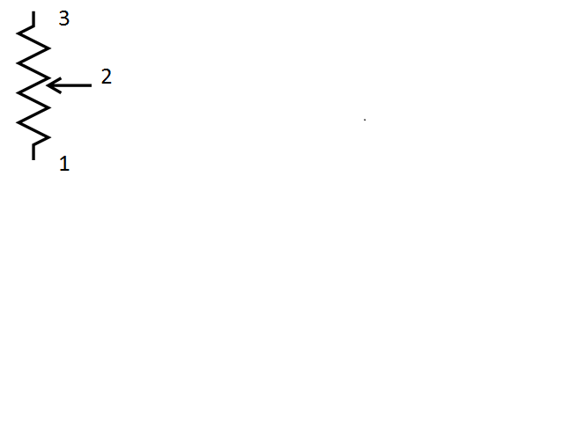

Electrolytic Capacitor:

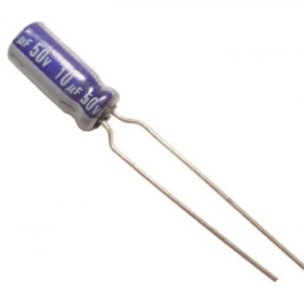 

Transistor:

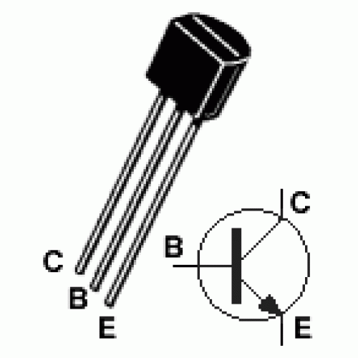

**Schematics**:

Simple LED Circuit

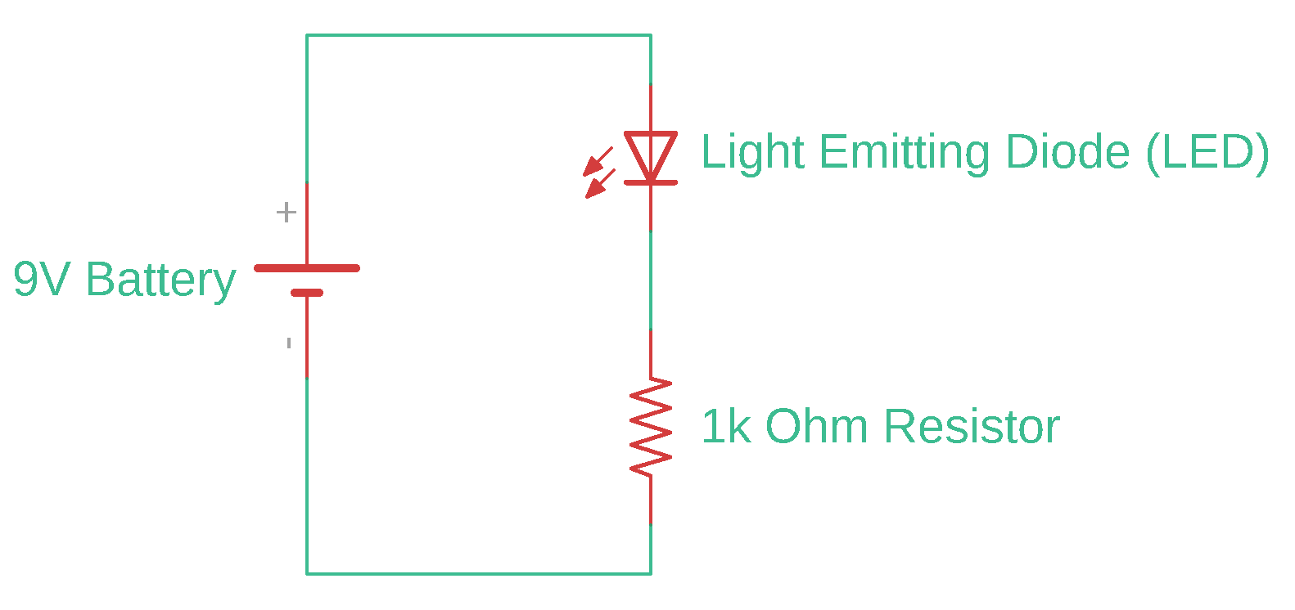

Dimmer Circuit

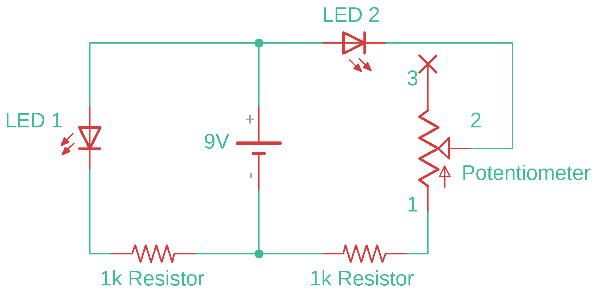

Welcome to the Resistance Circuit

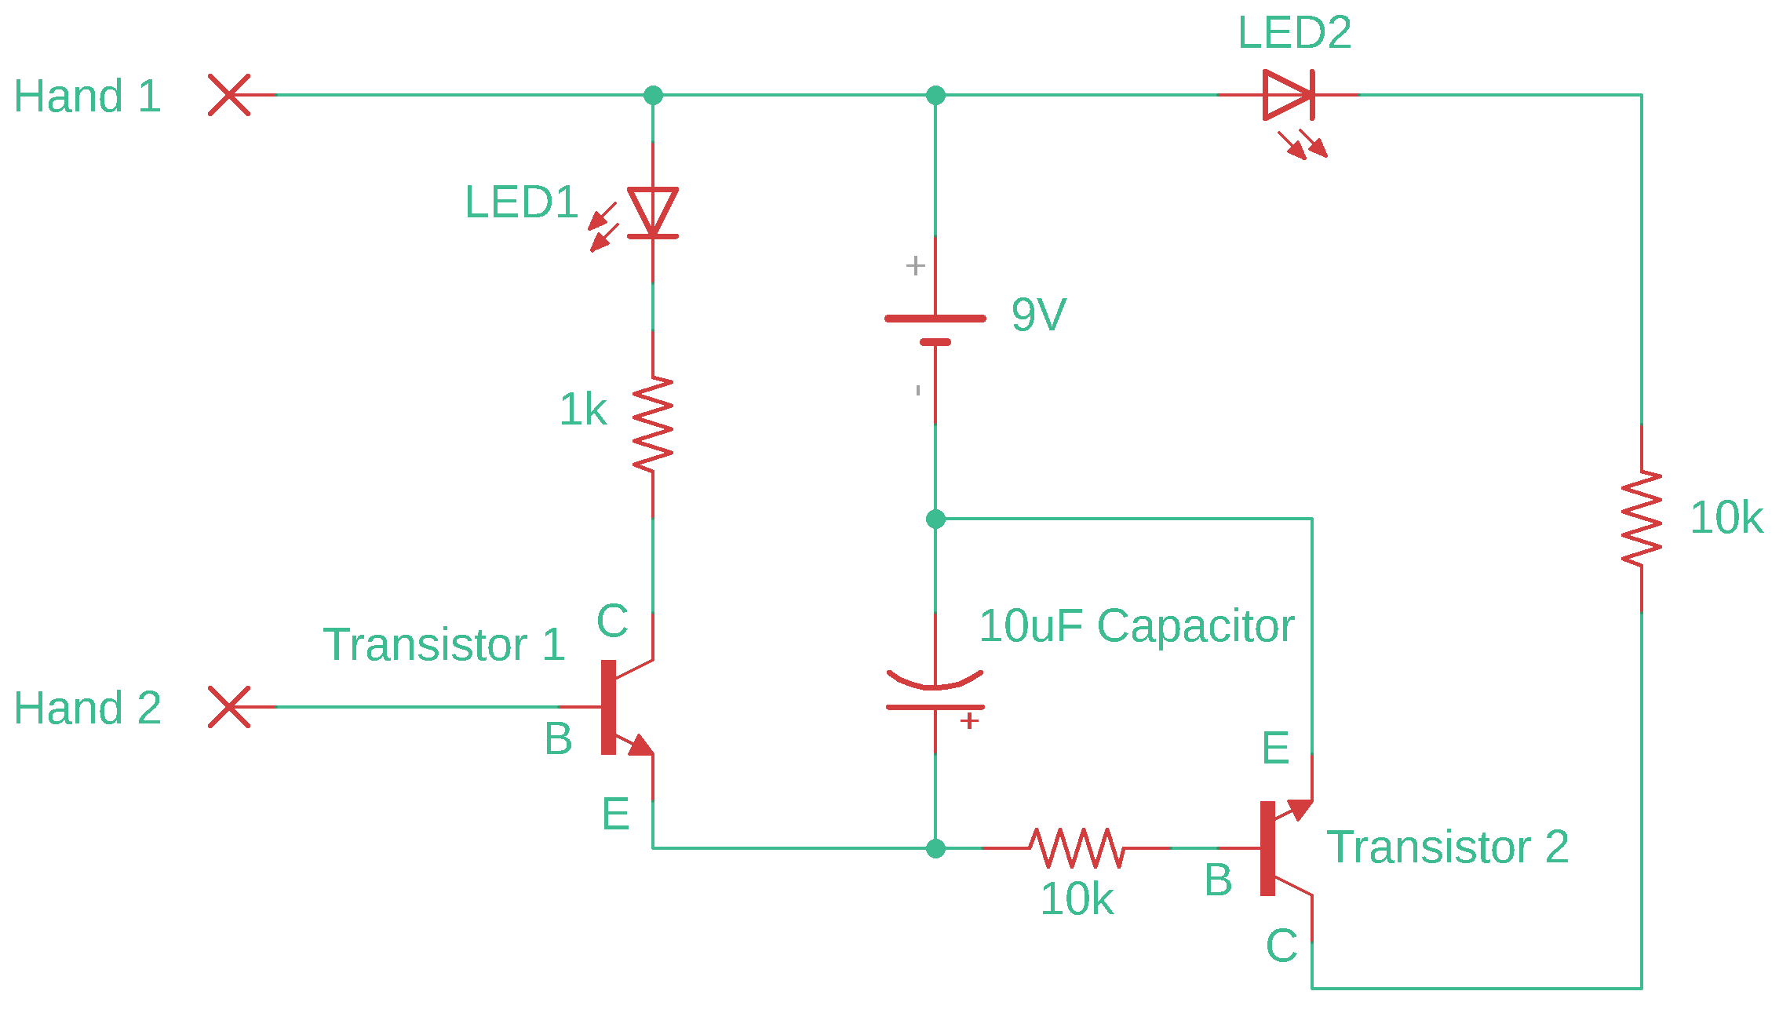

Simple LED Circuit:

First, acquire all the components listed below before you begin making this circuit:

1. Breadboard
2. Battery and Battery Snap
3. LED
4. 1kΩ Resistor (brown, black, red, gold)
5. Jumper Wire (Optional)

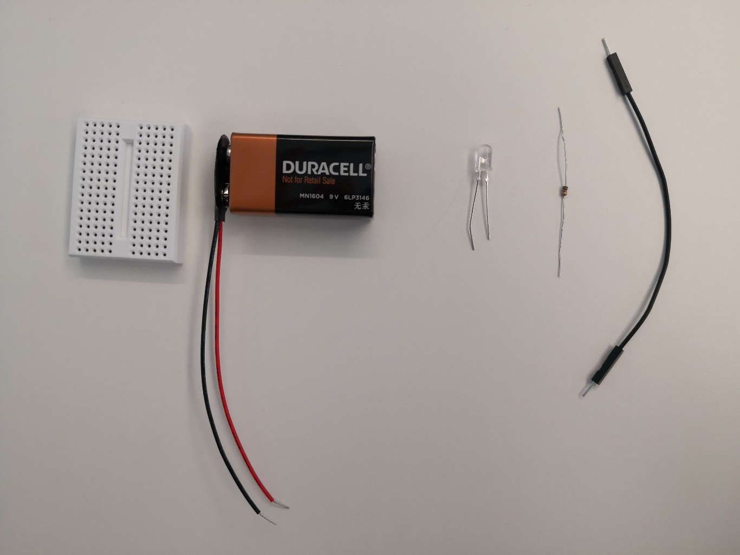

Put the LED in the breadboard, where the LED’s longer lead is in the same row on the breadboard as the red lead of the battery snap. Otherwise, nothing will happen!

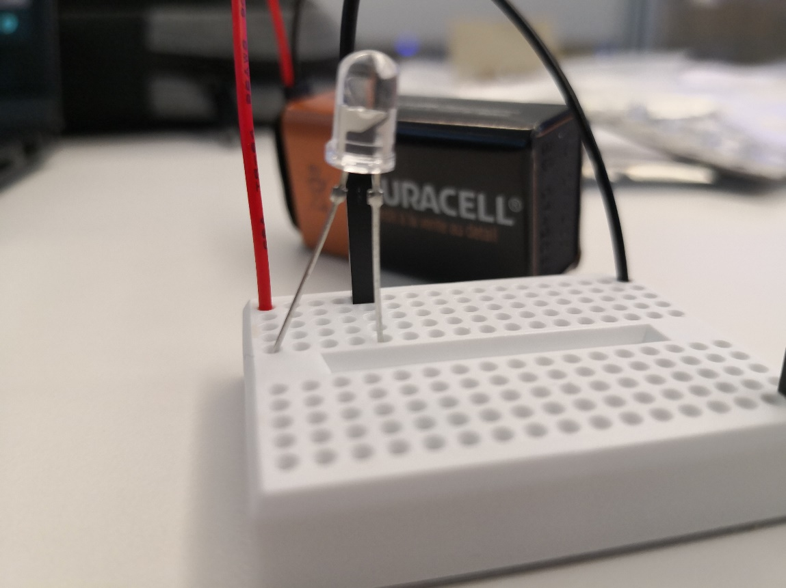

Longer lead on this side!

Once you complete the circuit, the LED should light up!

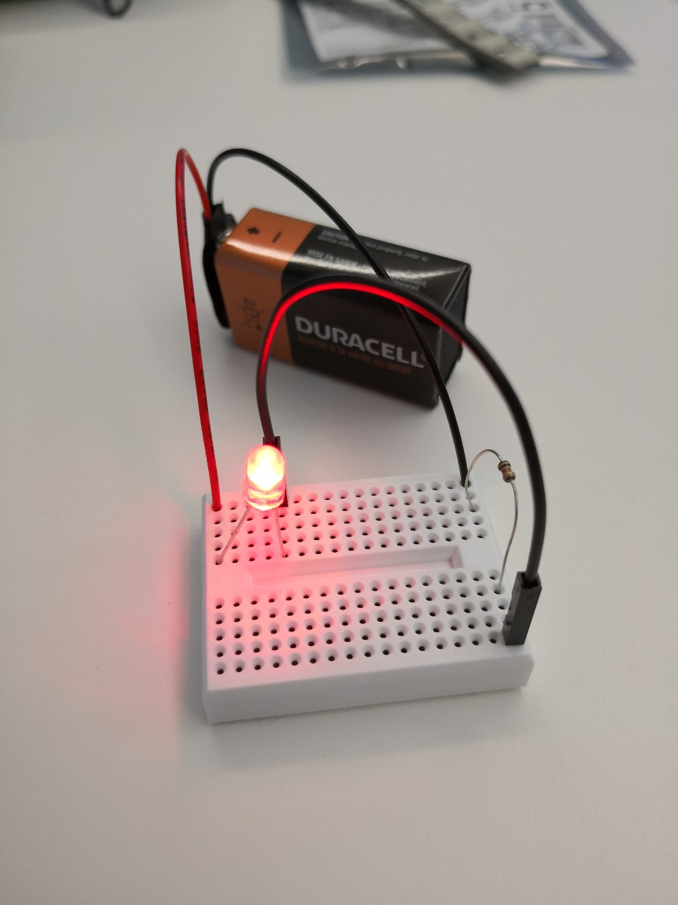

Basic LED Dimmer Circuit:

Gather the following components:

1. Breadboard
2. Battery and Battery Snap
3. 2 LEDS
4. 2, 1kΩ Resistors
5. Potentiometer
6. Jumper Wire (Optional)

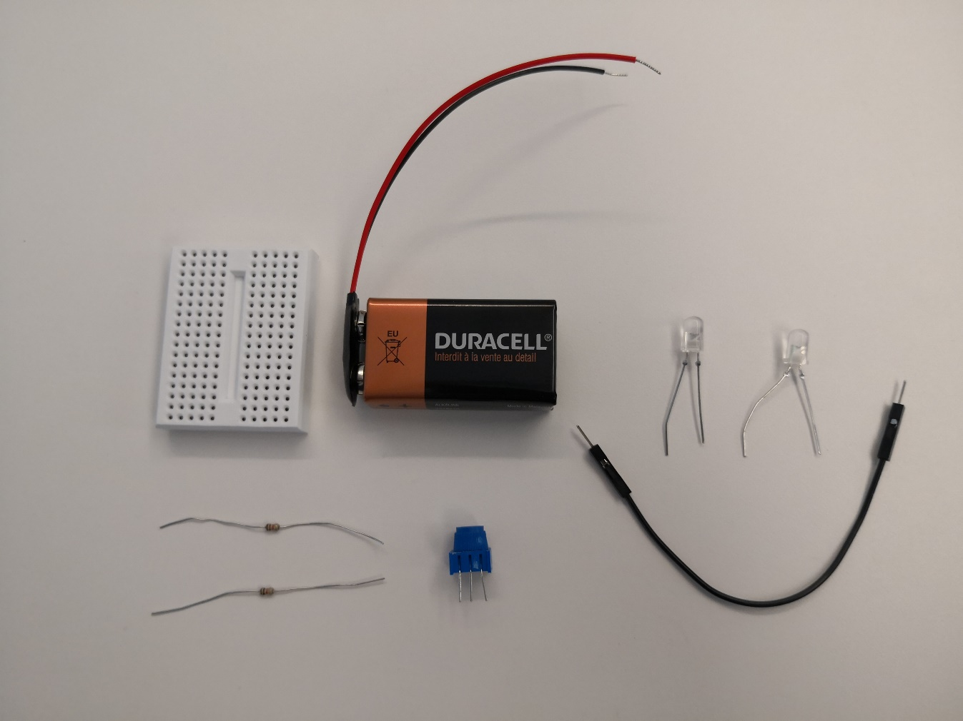

Remember that the longer lead of the LED needs to be in the same row as the red lead of the battery snap.

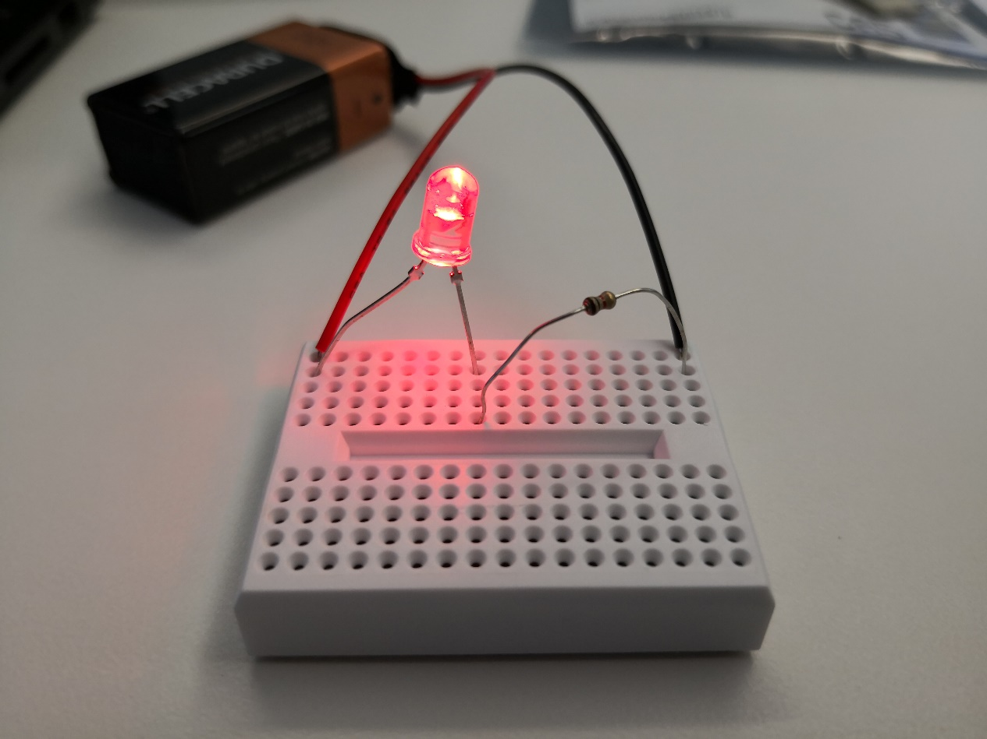

Longer lead here!

Make sure that the third lead of the potentiometer is NOT used. You can make sure of this by placing it at the end of the breadboard, such that its third lead hangs off of the side of the board.

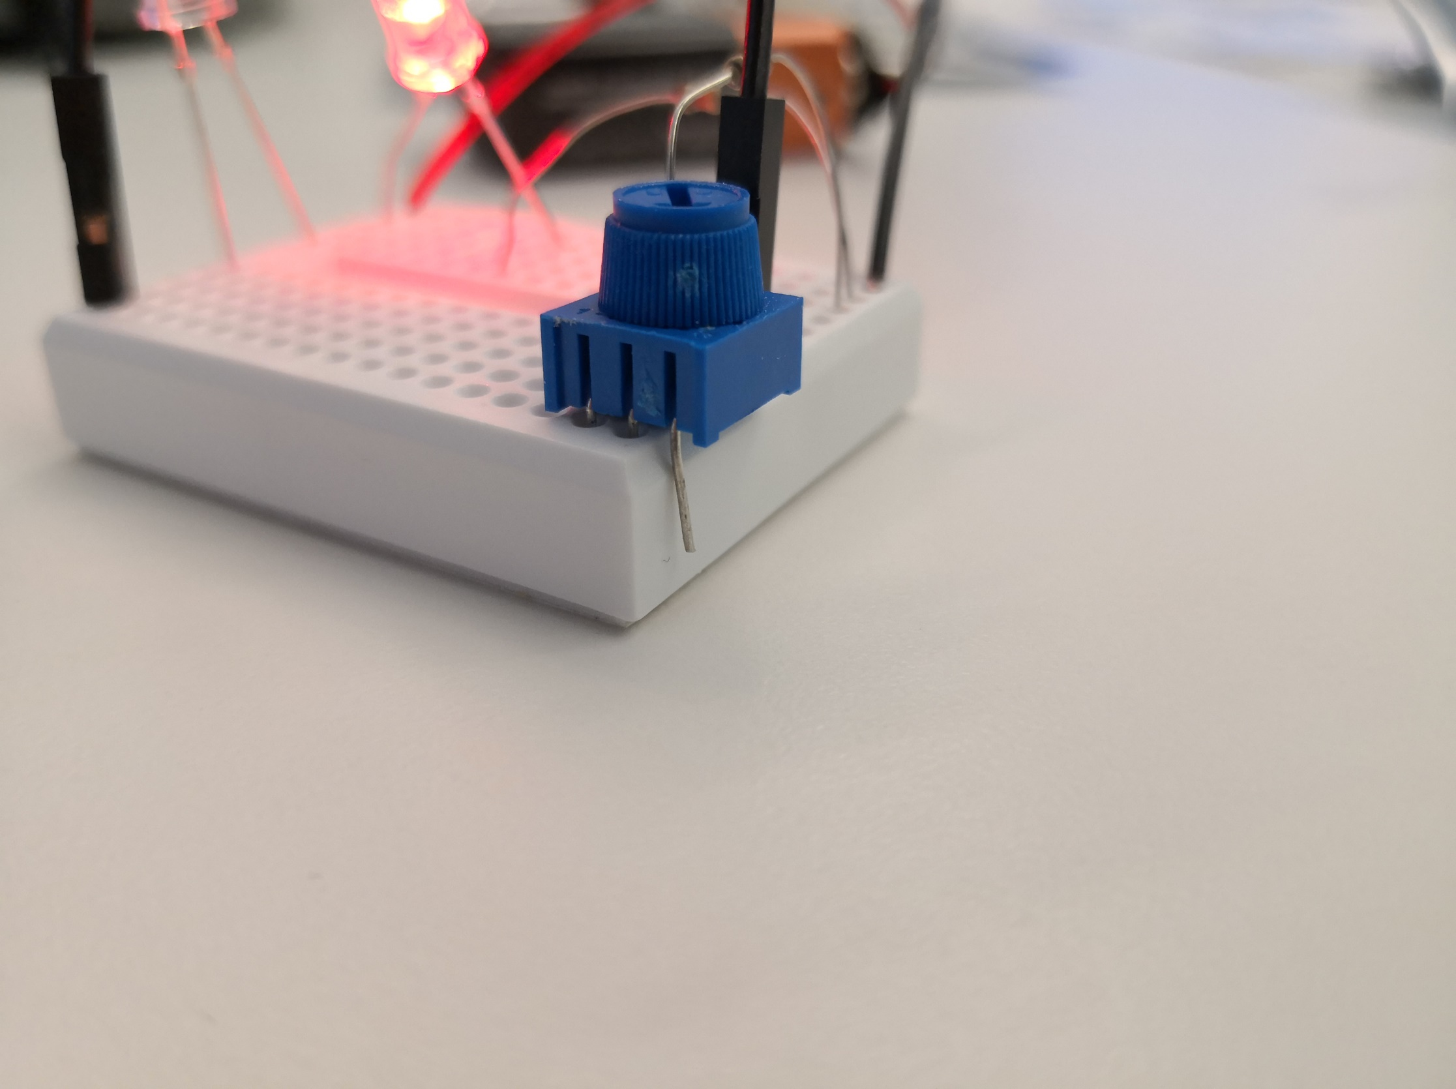

3

2

1

Make sure that lead 1 of the potentiometer is ONLY connected to the resistor, while lead 2 of the potentiometer is ONLY connected to the shorter lead of the LED. The leads of the potentiometer should NOT be in the same row.

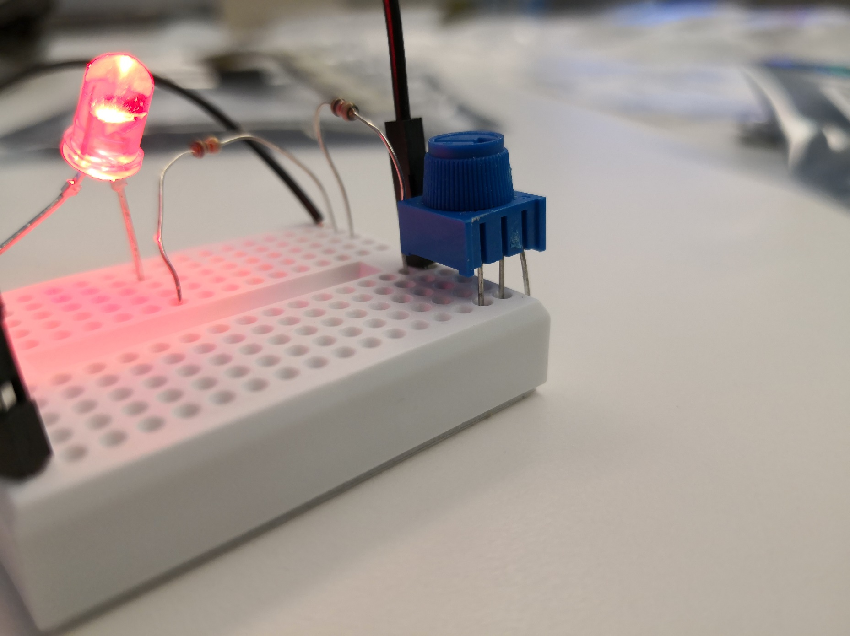

Below is the completed circuit. One of the LEDs should always be on, while the other one should dim and brighten when the knob on the potentiometer is turned.

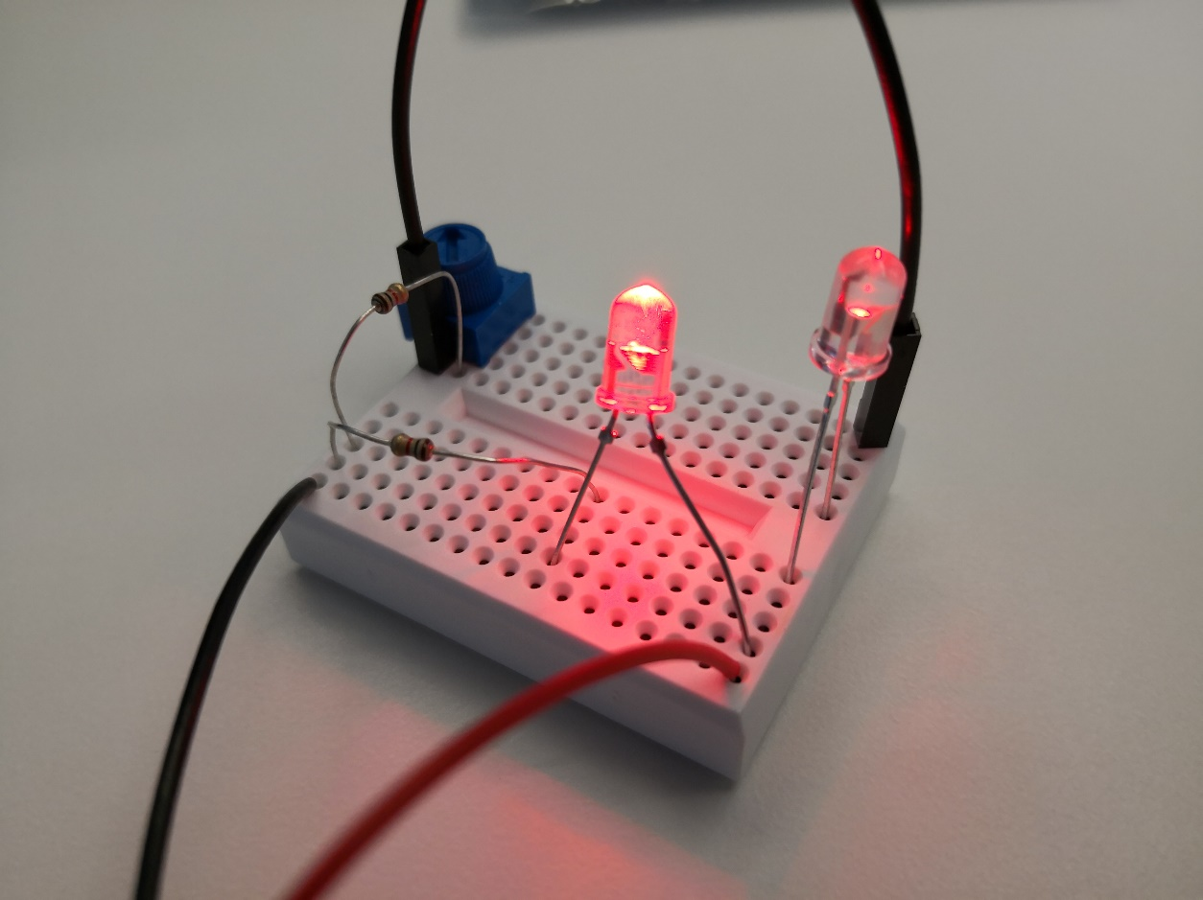

Welcome to the Resistance Circuit:

In order for you to join the resistance, you will need the following components:

1. Breadboard
2. Battery and Battery Snap
3. 2 LEDs
4. 3 Resistors:

* 1 1kΩ Resistor (brown, black, red, gold)
* 2 10kΩ Resistors (brown, black, orange, gold)

1. 1 10uF Electrolytic Capacitor
2. 2 Transistors
3. A few Jumper Wires (Required)

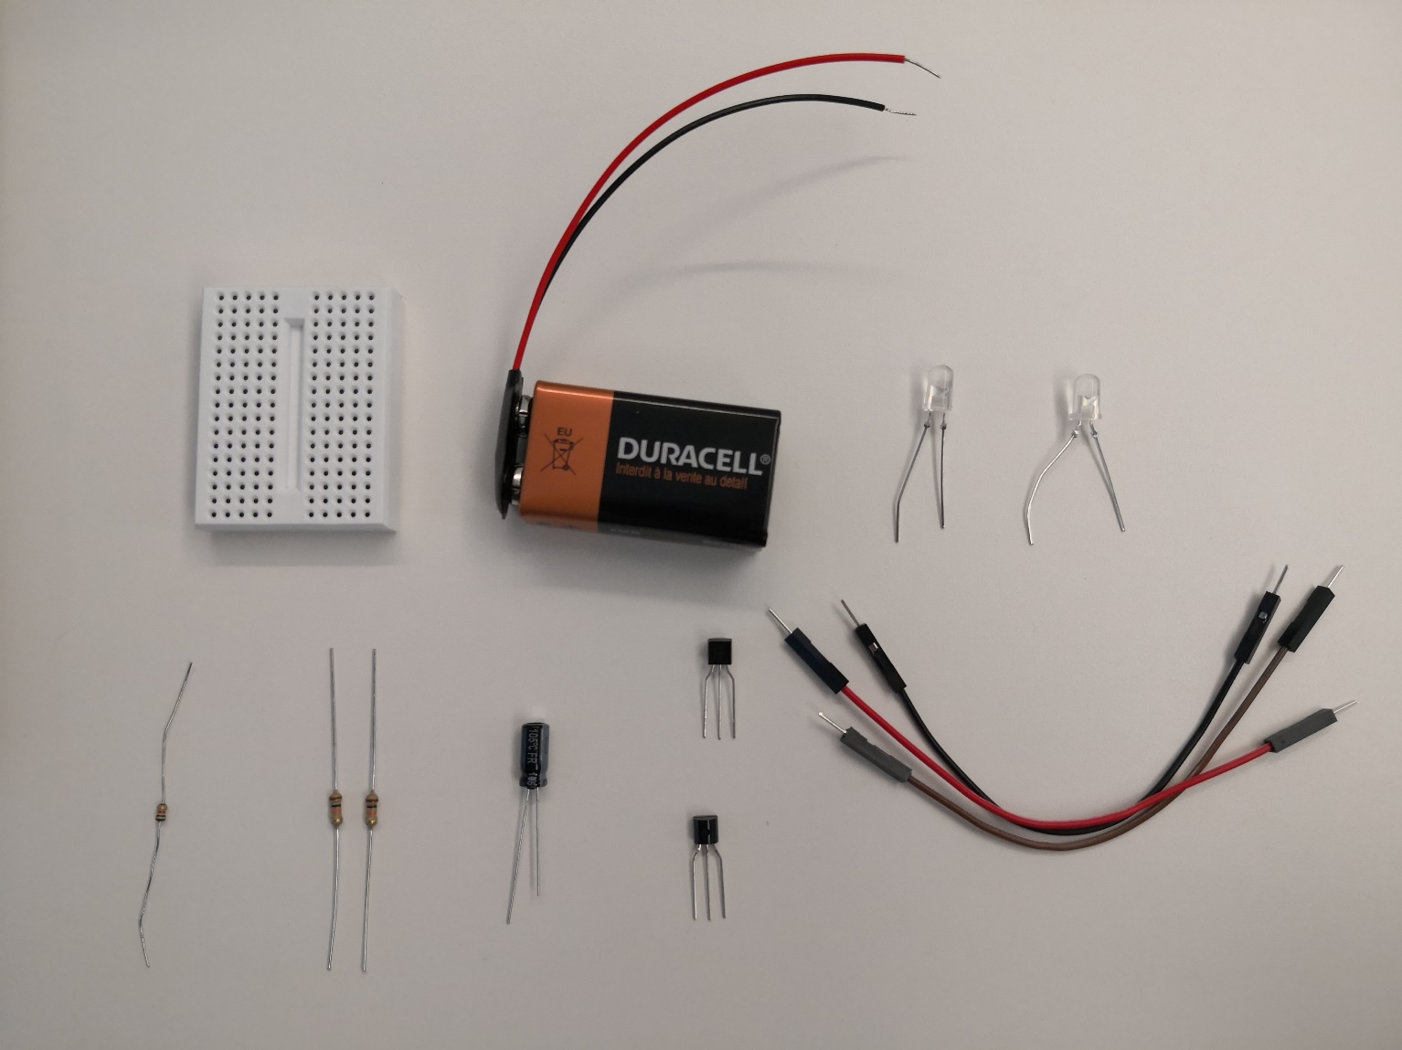

Make sure that the longer leads of both of the LEDs are connected to the same row as the red lead of the battery snap.

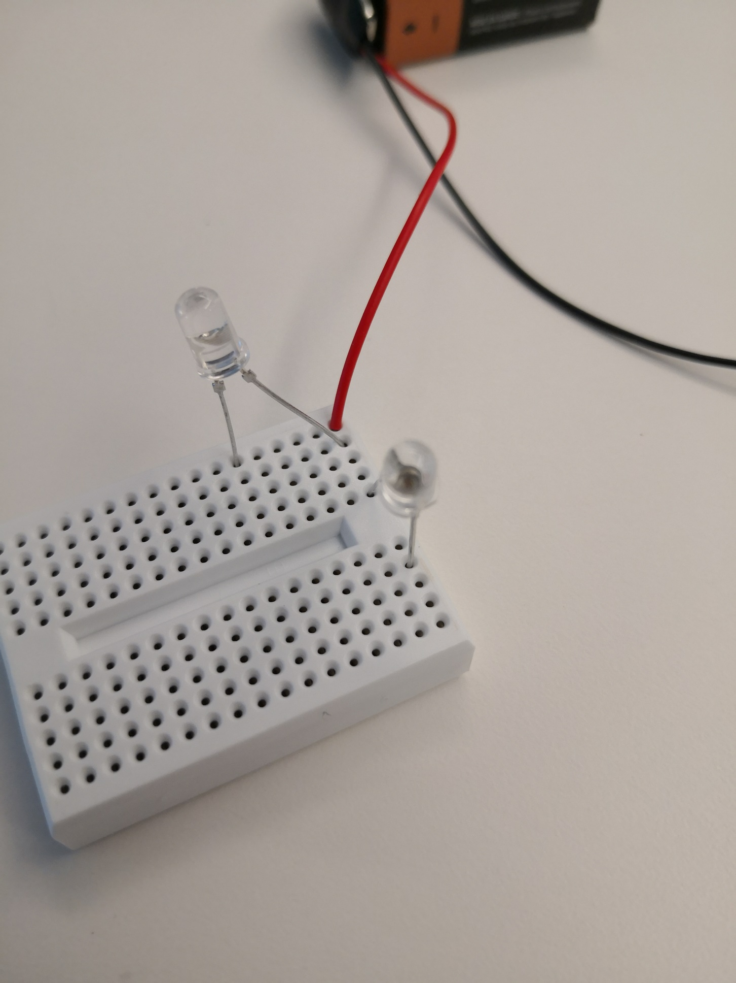

Longer leads here!

Next, install the transistors and **make note of their orientation**! **This is extremely important!!!**

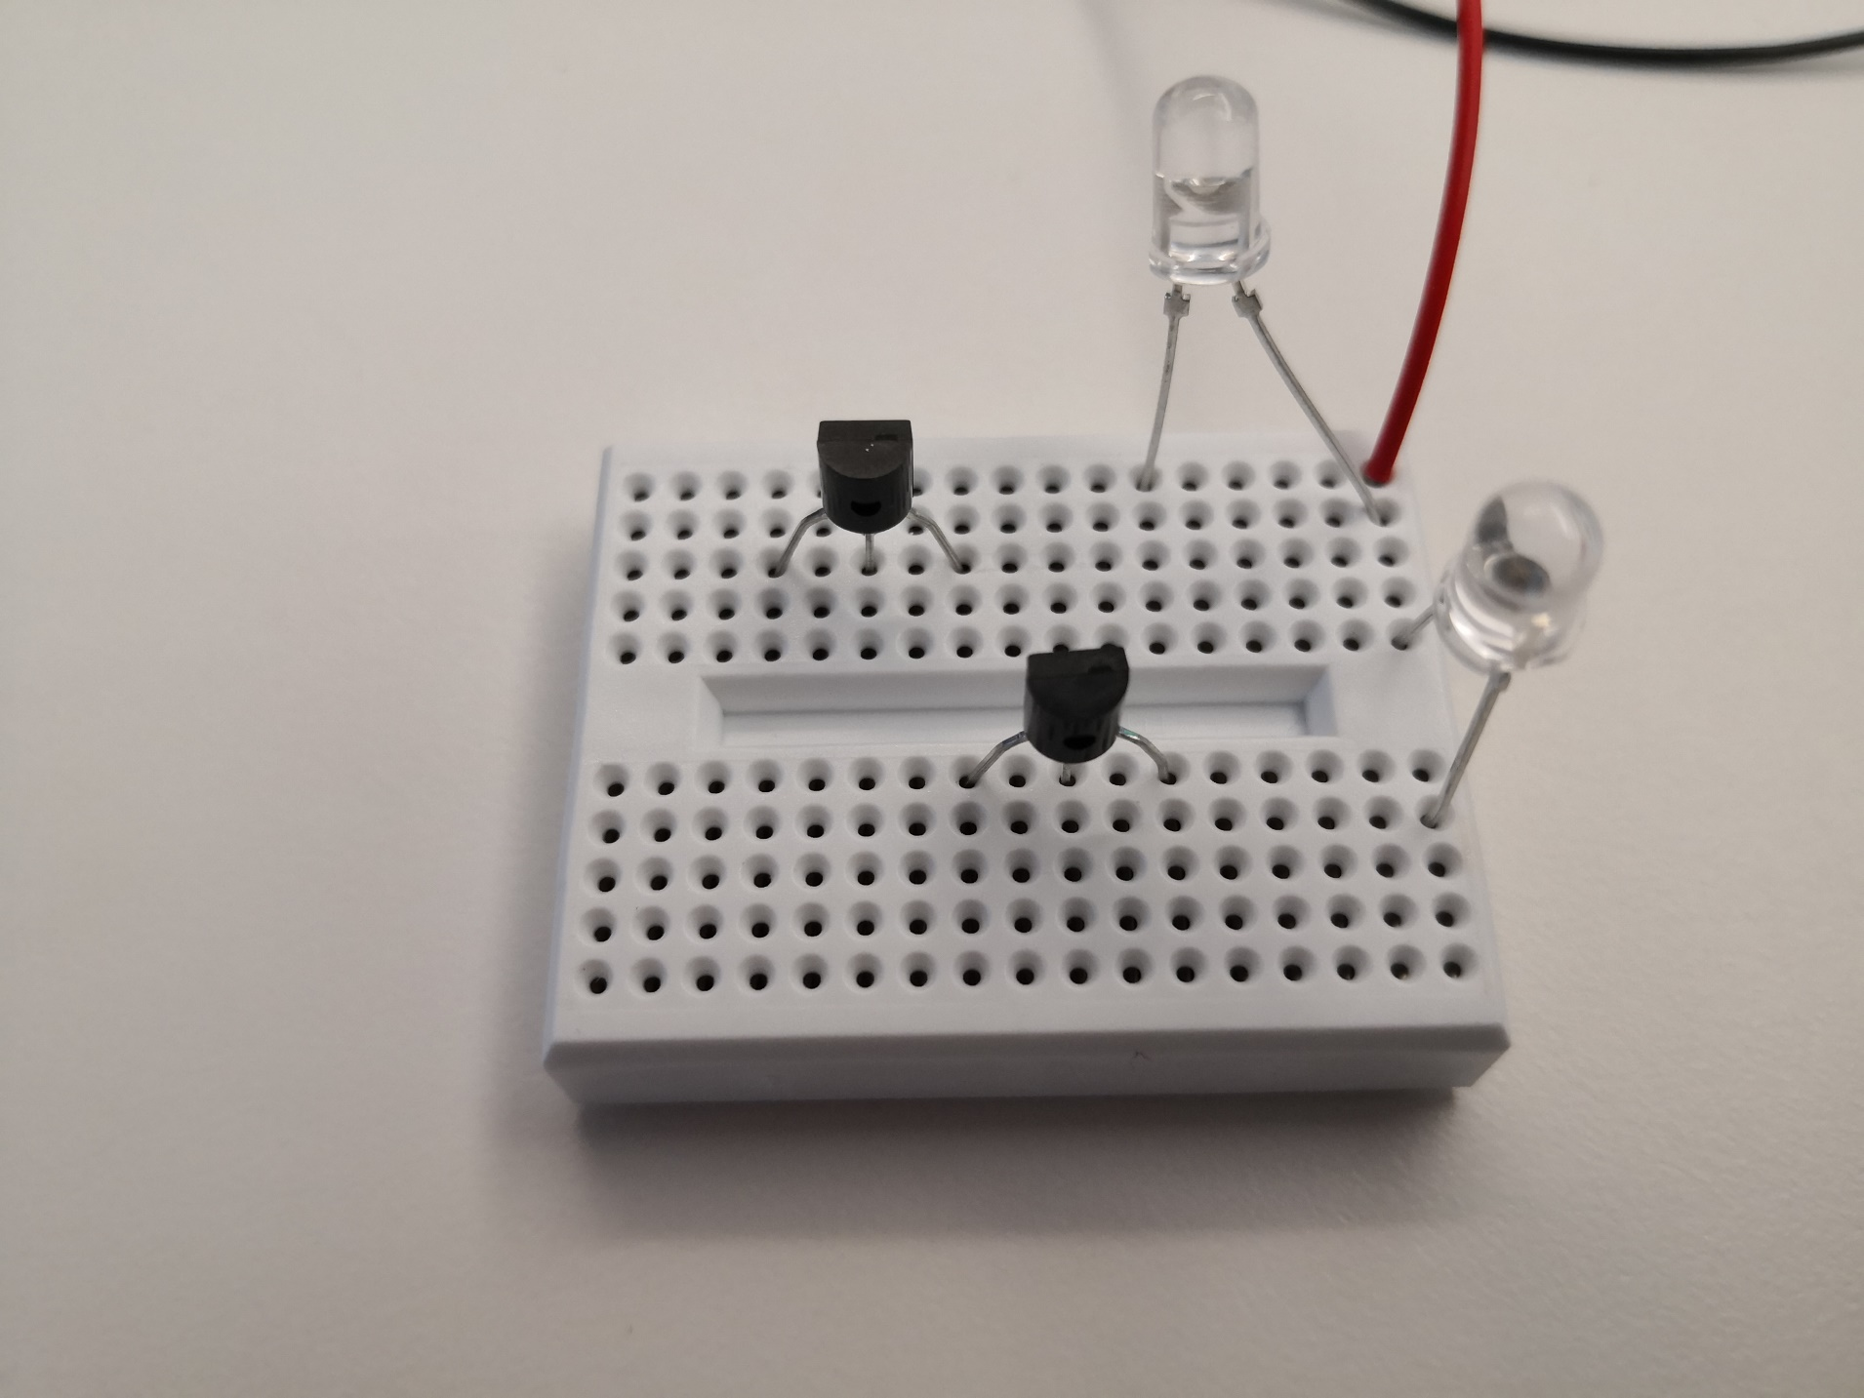

Install the resistors making note of which type of resistor goes where!

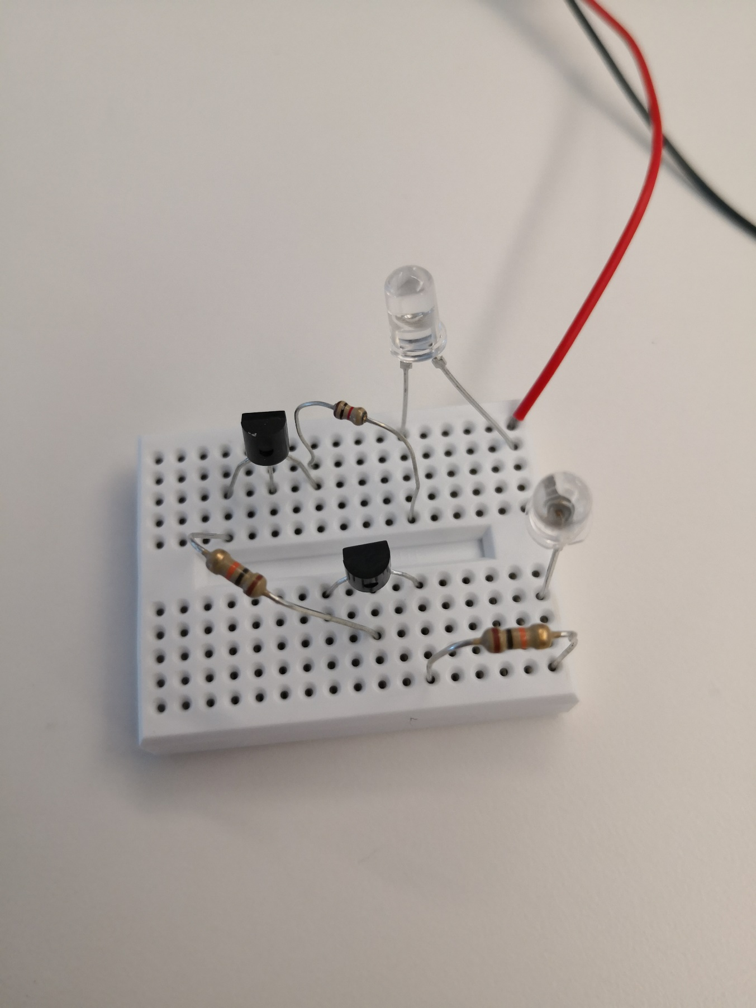

10kΩ

10kΩ

1kΩ

Install the capacitor making sure its longer lead is connected to the emitter of the transistor!

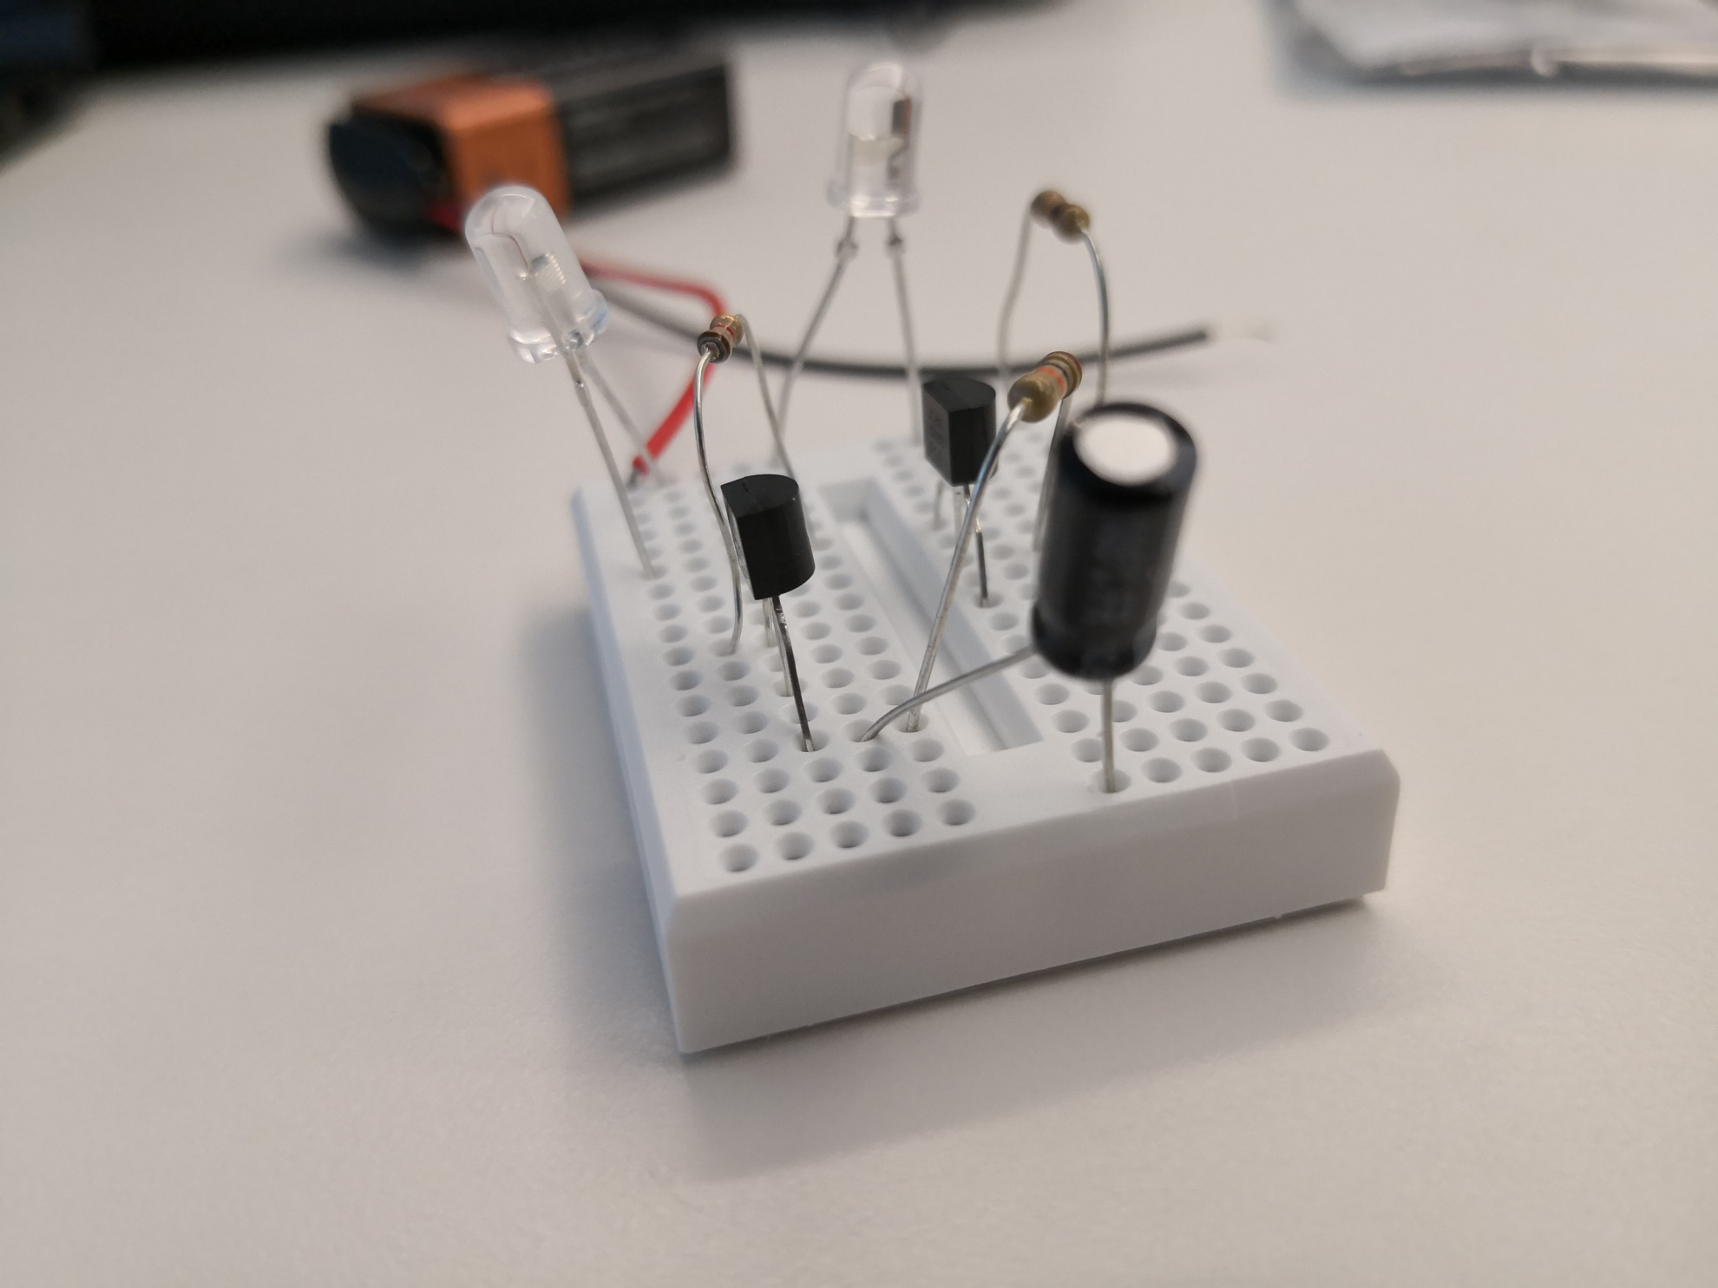

Longer lead here!

This is what the final circuit should look like. When you hold onto the ends of the two wires, both of the LEDs should light up. When you let go, one of the LEDs should turn off right away, while the other one should slowly dim until it no longer emits light.

